Baldwins Hill Primary School
Lowdells Lane, East Grinstead,
West Sussex, RH19 2AP
Tel: 01342 321572
Miss Jennifer Dabell – Headteacher

officebh@partnersinlearning.co.uk
www.baldwinshillprimaryschool.co.uk

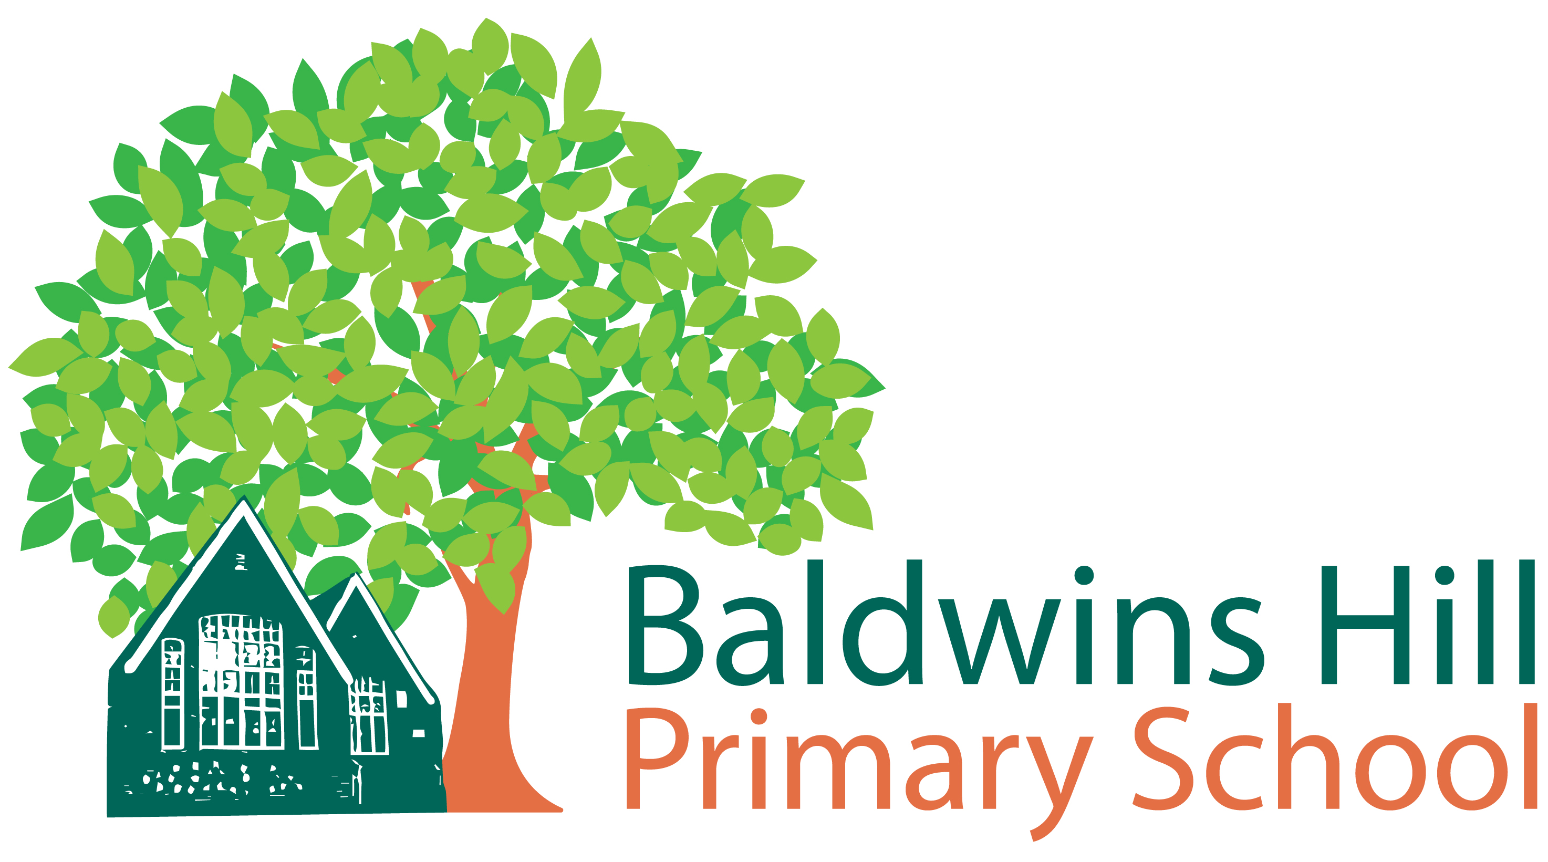

Uniform / Requirement List

Uniform can be ordered through our supplier by following this link: http://www.brigade.uk.com
Boy’s uniform requirements:
School sweatshirt
School Polo Shirt
Black/Grey trousers/shorts
Black/Grey Socks
Black shoes

PE Kit:
School T-Shirt
Black/Navy shorts
Black Plimsolls
Black/Navy jogging bottoms (optional)

Girl’s uniform requirements:
School sweatshirt/cardigan
School Polo Shirt
Black/Grey skirt /trousers
Green & White Gingham Summer dress
White socks
Black shoes
PE Kit:
School T-Shirt
Black/Navy shorts
Black Plimsolls
Black/Navy Jogging bottoms (optional)

Sweatshirts:
£13.00
Ages: 3-4 years
5-6 years
7-8 years
9-10 years
11-12 years
13 years
XS
S
Cardigans:
£14.60
PE T-shirts:
£7.99
Ages: 3-4 years
5-6 years
7-8 years
9-10 years
11-12 years
13 years
XS
S
Cap Book bag
£6.25 £7.95
Polo Shirts:
£11.35
Ages: 3-4 years
5-6 years
7-8 years
9-10 years
11-12 years
13 years
XS
S
Rucksack PE Bag
£12.95 £5.45

We encourage children to leave larger bags at home and to only bring in their PE Kit, lunch box and book bag. Each child is given their first book bag free of charge when they start at Baldwins Hill. Children will have their stationery provided for them by the school.

