

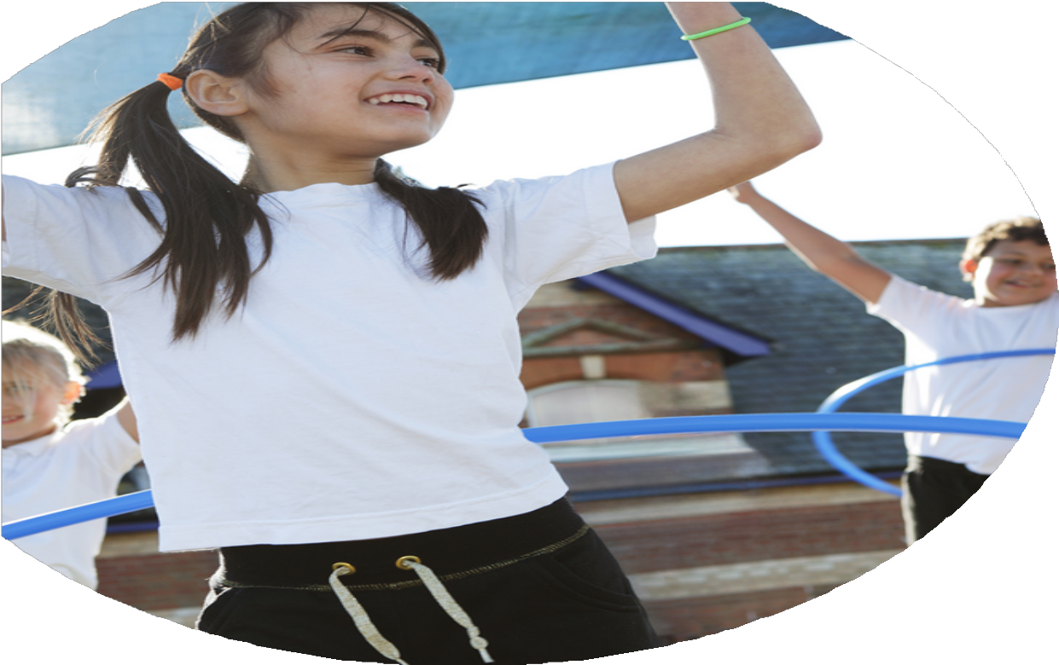
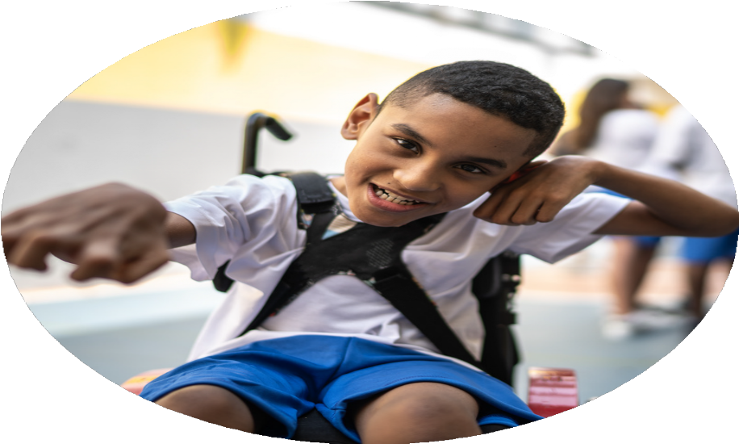




PE Funding

Evaluation Form

Commissioned by

Created by

Images courtesy of Youth Sport Trust

PE Funding Evaluation Form

It is intended that this template should be used as preparation for the completion of the statutory digital reporting tool being introduced this academic year. You can upload data (including swimming) from this template onto this platform once it becomes accessible.
Before you decide how you are going to use the funding for this academic year you should reflect and evaluate the impact of your use of the funding in 2023/24.
All spending of the funding must conform with the terms outlined in the Conditions of Grant document. The template is a working document that you can amend/update during the year.
Based on your evaluation of last year’s funding you should decide what you intend to do this academic year, how you will do it, and what impact you expect it to have.

It is important that the funding is used effectively and based on your school’s needs.
You must use the funding to make additional and sustainable improvements to the PE and sport in your school. You must develop and add to the PESSPA activities that your school already offers.

Summative digital reporting from June 2025 will continue to include swimming and water safety information therefore funding can be used to provide top-up lessons where necessary to ensure pupils meet national curriculum swimming requirements.

Review of last year 2023/24
We recommend that you start by reflecting on the impact of current provision and reviewing your previous spend.
What went well?
How do you know?
What didn’t go well?
How do you know?

- Provide opportunities to participate in competitive sports and in sports festivals so that children get the opportunity to try new sports. With a focus of disadvantaged learners attending.
- 100% of teachers to be following consistent approach in PE teaching.
- Develop the role of the PE Champion and staff by accessing a variety of CPD opportunities.
- Encourage participation in physical activities at lunchtime to gain the status of 30 active minutes a day per child.
- Ensure a range of clubs are offered to enable all learners to participate in physical activities and sports.
- To ensure all Year 6 children get the opportunity to meet national curriculum aims for swimming.
- To promote the safe use of bikes and encourage children to use an active way of transportation to school.

- Ensuring that sports crew leaders are a long term implementation into lunchtimes.
- Ensuring that a broader age range of children get to experience sports events.
- To ensure underserved learners ae accessing clubs

- Teachers and children report that better timetabling and rotas need to be put in place to ensure sports crew leaders can lead sessions. Due to other circumstances we didn’t get to train any new sports crew leaders this academic year.
- From our data no children from year R/1 went out of school to represent the school. We have shown a focus on KS2.
- In recent data club levels have dropped.
- 52/55 Year 5 and 6 children have attended a sporting event over the year 23/34. Only 1 Disadvantaged Learner did not attend an enrichment activity held out of school, due to personal preference.
- Children from Year 1, 2, 3 and 4 have also had the opportunity to take part in events. We have targeted Disadvantaged Learner children to attend as a priority.
- Children from a range of Year groups have reported positive feedback through learner voice questionnaires. See quotes below.
- 25/33 Disadvantaged Learners have attended sports clubs this academic year.
- 100% Children who required extra swimming lessons were identified and all children identified as not meeting the aims got the opportunity to practice essential areas of the curriculum including lifesaving.
- 23 Year 6 children participated in the bike ability course. 100% of learners who took part successfully passed their level of the course.

Intended actions for 2024/25
What are your plans for 2024/25?

Intent
How are you going to action and achieve these plans?

Implementation

- Teachers to offer free clubs.
- Premier Sports coaches to offer clubs with no cost to families.
- Football coach to offer football club at no cost to families
- PTA to fund martial arts club
- Play equipment bought for the playground
- Playground markings
- New PE scheme purchased May 2022 – to be implemented Autumn term 2023 and continue throughout the academic year starting 2024.
- CPD deliverd by Caroline Stafford
- PE champion completed CPD
- Subscribe to Mid-Sussex active to ensure learners will have the opportunity to participate in competitive sports and a wide range of sporting activities such as festivals.
- Supply costs to ensure children can be taken to sports events
- Leagues, competions and festivals atteneded throughout the yea.

- Ensure a range of clubs are offered to enable all learners to participate in physical activities and sports.
- Encourage participation in physical activities at lunchtime to gain the status of 30 active minutes a day per child.
- 100% of teachers to be following consistent approach in PE teaching.
- Provide opportunities to participate in competitive sports and in sports festivals so that children get the opportunity to try new sports. With a focus of disadvantaged learners attending.

Expected impact and sustainability will be achieved
What impact/intended impact/sustainability are you
expecting?
How will you know? What evidence do you have or
expect to have?

55/60 Year 5 and 6 children have attended a sporting event over the year 23/34. Only 2 Disadvantaged Learner did not attend an enrichment activity held out of school, due to personal preference, they were invited to attend multiple opportunities.

Children from Year 1, 2, 3 and 4 have also had the opportunity to take part in events. We have targeted Disadvantaged Learner children to attend as a priority.
Y2- 12/18 children (1/1 PP)
Y3- 18/22 children (4/5 PP) PP that didn’t attend was due to sprained ankel
Y4-28/30 children (8/8 PP)
Y5- 28/28 children (1/3 pp)
Y6-27/32 children (2/4) PP
Children from a range of Year groups have reported positive feedback through learner voice questionnaires. See quotes below.

Action- Provide opportunities to participate in competitive sports and in sports festivals so that children get the opportunity to try new sports. With a focus of disadvantaged learners attending.

What did we do?
Subscribe to Mid-Sussex active to ensure learners will have the opportunity to participate in competitive sports and a wide range of sporting activities such as festivals.

Sustainability: Continue to sign up to mid Sussex Active in order to have provided opportunities for the children to engage in- ensure opportunities for new staff and ECT to attend events with more experienced staff to build confidence.
Children continue to celebrate their achievements with others in assembly and on the display board in the corridor to raise the profile and engagement of others.

The Mid-Sussex Active Subscription is £3,500.

Actual impact/sustainability and supporting evidence
What impact/sustainability have you seen?
What evidence do you have?

100% Teachers have said the scheme of work has made them more confident to teach PE because they are clearer on the expectations and ensuring a clear progression.

Feedback from teachers-
“I find it easy to follow, good that there are the in depth plans and simple plans.”

“Yes, the planning is easy to follow and use”

“It is easy to follow, sometimes I adapt it to met the needs of my class but it is easy to see the progression of other year groups in comparison”.

7/7 Teachers would like to keep the scheme that we currently use.

Quotes from children about PE lessons-

“I like that there are active lessons that lots of us enjoy. There are very fun activities and I love them.”

“In PE lessons I enjoy all the activities to warm up to get us ready for the lesson.”

“Our teachers make PE lessons fun and active.”

“I like being able to try different sports.”

“I like that the sports change so that we are not always doing the same.”
Action- 100% of teachers to be following consistent approach in PE teaching.

What did we do?
New PE scheme purchased May 2022 – to be implemented Autumn term 2023 and continue throughout the academic year starting 2024.
Evaluate the overview for PE across the school and send out new yearly overview to all teachers for the start of September 2024.

All staff to complete CPD session planned for a staff meeting

Sending teachers sports events to gain experience at different sports

Sustainability: New teachers joining September to have induction around the PE curriculum and scheme.

£238.80 to renew our PE planning subscription
£120 for CPD costs

When children were asked in a short survey all children agreed that they were receiving their 30 active minutes a day and the equipment and resources such as the playground markings had an impact on this.

Children are timetables trim trail sessions 3 times a week which gives them the opportunity to use the climbing resources and the section of AstroTurf to play football. Children are also timetables to have 2-hour PE lessons a week. This along with playground equipment, interactive playground markings, brain brakes, ana active lessons ensures that all children have the opportunity to access 30 active minutes a day in school.

Action- Encourage participation in physical activities at lunchtime to gain the status of 30 active minutes a day per child.
What did we do? Purchasing a range of playground equipment to encourage children to be active within their break and lunchtimes.
-Football goals
-Skipping ropes
-Stilts
-Bats and balls
-Hula hoops
-Scoops and balls
Sustainability:
Playground equipment to be kept safely and in the new academic year monitors will be given the role to look after equipment and take out/pack away for break and lunchtimes. Playground markings have a ten year guarantee.

Purchased new playground markings that encourage physcial activities and games during lunchtime.
-Sports court
-Fitness trail
-Phonics/maths/spanish interactive games

£4782 for playground markings

Action- Ensure a range of clubs are offered to enable all learners to participate in physical activities and sports.

What did we do?
Teachers to offer free clubs.
Premier Sports coaches to offer clubs with no cost to families.

Joel Grey coaching offerning weekly football club
Clubs offered
-Football
-Multisport/skills
-Cricket
-Hockey
-Netball
-Cross country
-Multi sports
-Rounders
- Dance
-Martial arts
Sustainability: to continue to raise the profile and put importance on clubs, especially for disadvantaged learners

Football coaching £55 per week
Pemiere sports £4560
All learners, including disadvantages learners have, have voiced they had positive experiences attending sports clubs.
100% of disadvantaged learners have been offered and encouraged to join clubs with conversations with parents to promote these. Additional spaces have been created, where necessary to encourage attendance.

11 disadvantaged learners attended sports clubs this year and all disadvantages children were offered places at a sports club.

Children voice
“Next year I want to join all the sports teams”
“I enjoy going to sports after school clubs”
“I love Mr Greys football club”

Next year we are aiming for this to be higher and are offering children free places at kicks dance club to encourage children who prefer dance as a sport to be active.

100% Children who required extra lessons were identified and all children identified as not meeting the aims got the opportunity to practice essential areas of the curriculum including lifesaving.

All children have shown an improvement in confidence in the water.

68% of children have now met the national curriculum expectations. We sent 17 children to attend extra top up lessons. 100% of children that we sent can now swim a length in a stroke of their preference and safely self-rescue.

Action- To ensure all Year 6 children get the opportunity to meet national curriculum aims for swimming.

What did we do?

Year 6 swimming assessment for all children.

Intensive swimming course for 10 learners who did not meet curriculum goals.

Sustainability- Children can use these skills throughout life and are essential for life saving if children find themselves in a dangerous situation.

£75 to King centre for assessment.

£128 per week to the Kings Centre for intensive course.
£128x5= £640

32 Year 6 children participated in the bike ability course. 100% of learners who took part successfully passed their level of the course. 4/4 Disadvantaged learners took part and passed.

Year 5 this year also took part in the level one bike ability lessons. The whole class (28 children) passed the first level in preparation for year 6.
Action- To promote the safe use of bikes and encourage children to use an active way of transportation to school.
Walk to school week led by our eco- champion. Launched in an assembly and tracked in classes.
Bike ability- The cycle training programme. It helps you learn practical skills and understand how to cycle on today’s roads.

Year 6 completed bikeability
EY completed balance bikability
Year 5 completed level 1

Sustainability- Children can apply the skills they have learnt throughout secondary school and the rest of their life.

£10 per child x 32 = £320 (Year 6)
100% Parents have received termly newsletters to update them on sports events.

Sporting events have been discussed at parent forums. Targets have been formed based on feedback from parents.

We have had very positive feedback from parents, children and staff regarding the DJ and the positive atmosphere created on sports day.

From great athletes we raised £1900 fo the school to buy sports equipment while raising the profile of sports from a motivational assembly.

Action- To raise profile of PE and sport within the school community (staff, pupils and parents).

What did we do?
PE champion/s to attend Mid Sussex PE course outlining the events for this year. (Sept 22)
PE Champions to be released from class for a total of 1 day per term (Cover supervisor)
DJ to attend Sports Day to make it a more remarkable experience for the children and parents.
School Sport/PE display
Produce own termly sports letter
Martial arts assembly
Assembly from proffesional badminton player.

DJ £170

