Baldwins Hill Primary School
Lowdells Lane, East Grinstead,
West Sussex, RH19 2AP
Tel: 01342 321572
Miss Jennifer Dabell – Headteacher

officebh@partnersinlearning.co.uk
www.baldwinshillprimaryschool.co.uk

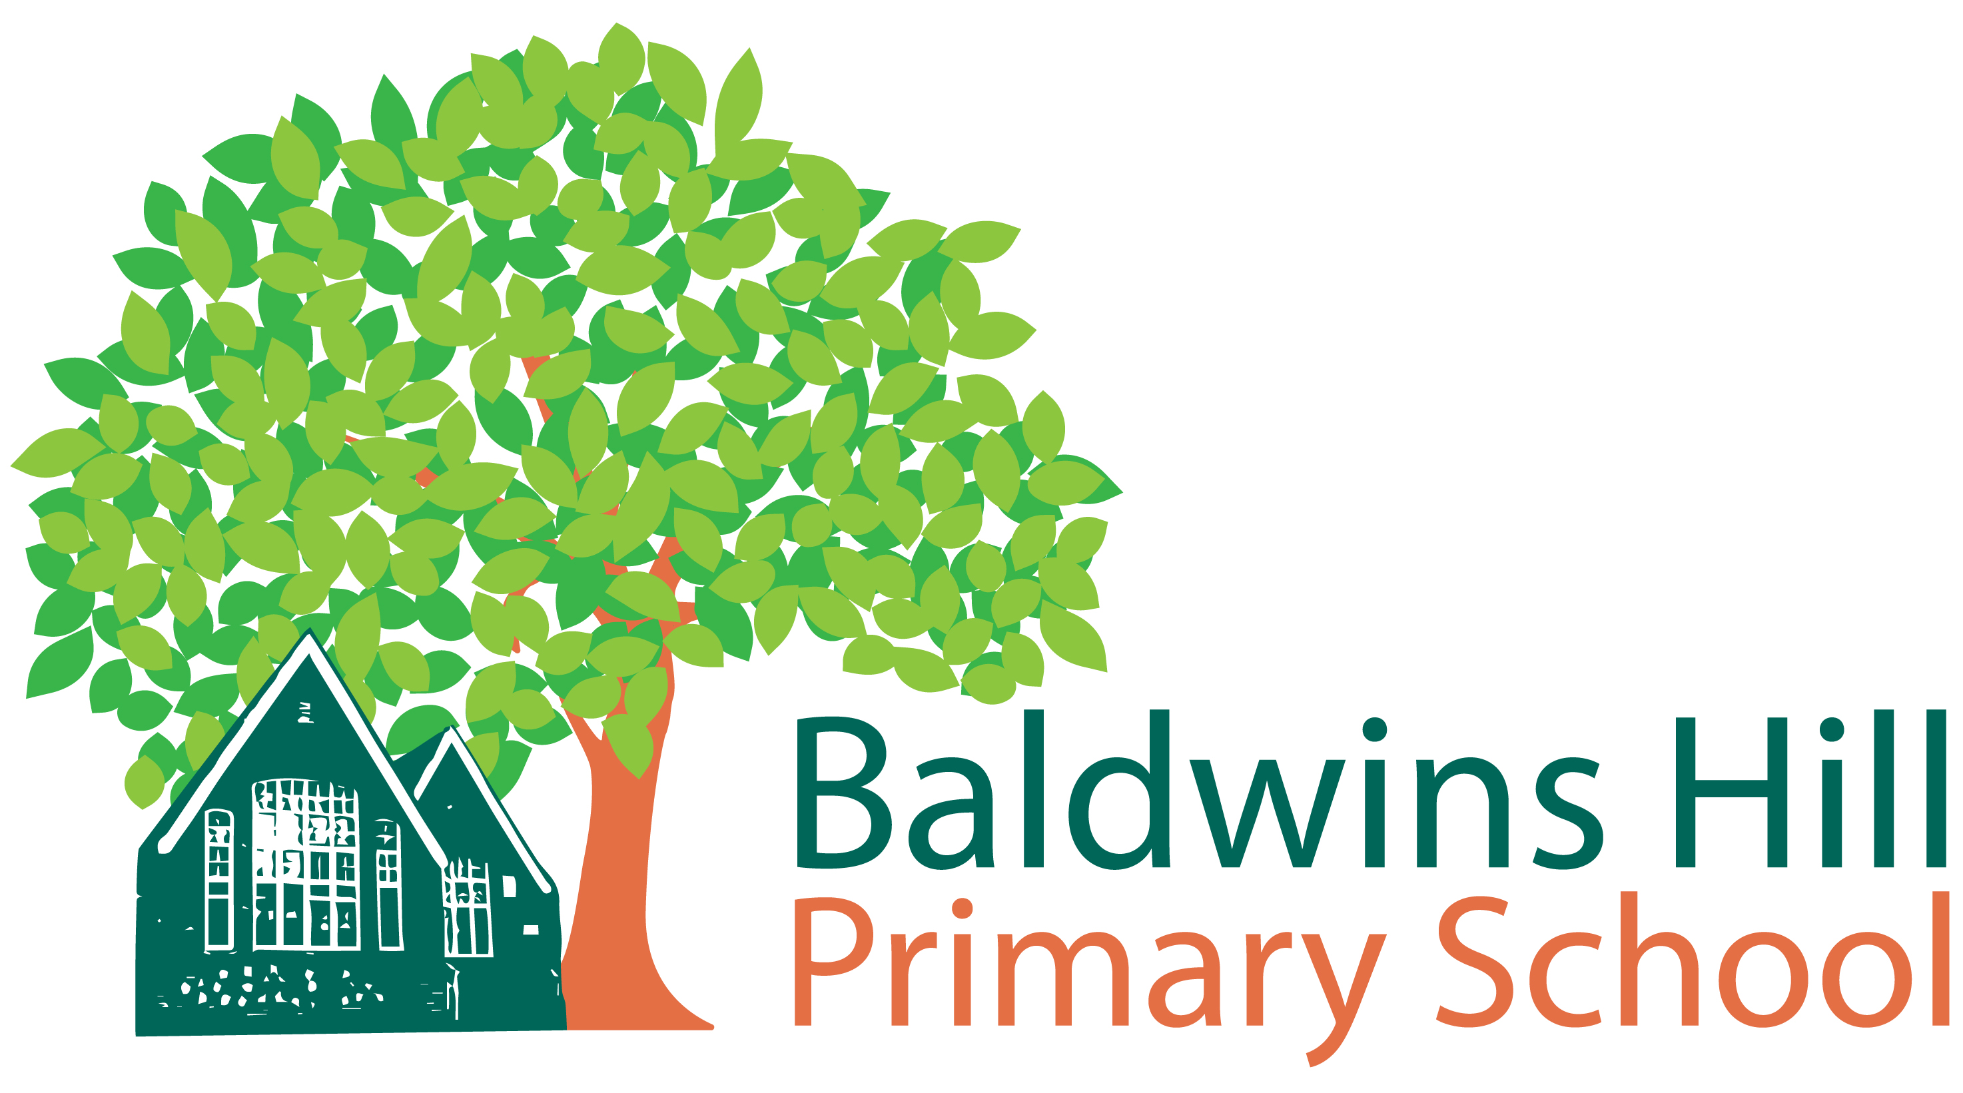

Parent/Carer consent to administer short-term non-prescribed ‘ad-hoc’ medicines
The school will not administer medication unless this form is completed and signed, no verbal permission will be accepted. This information will be kept securely with your child’s other records. If further information is required, we will contact you. Please do not hesitate to contact the school if there are any issues you wish to discuss.
Pupils Name | D.O.B
Gender | Class
The Medicines Policy permits the school to administer the following non-prescription medication if your child develops the relevant symptoms during the school day. Pupils will be given a standard dose suitable to their age and weight. You will be contacted prior to medication administration. You will be informed when the school has administered medication by letter. The school holds a small stock of the following medicines:
Paracetamol

Anti-histamine

Tick the non-prescription medications above that you give your consent for the school to administer during the school day and confirm that you have administered these medications in the past without adverse effect. Please keep the school informed of any changes to this consent.
I confirm that my child has previously received the above medications and not suffered any adverse reactions

____________________________________________ ___________
Signature(s) Parent/Carer Date
________________________________________
Print name

