Zones of Regulation

“Life is 10% what happens to us and 90% how we react to it.” Charles Swindoll
You many have heard your child talk about the Zones of Regulation. This is a system we use in school to help children learn how to accept and regulate their emotions. There are four zones into which emotions are arranged. These zones help children to explain how they are feeling, for example, “I am feeling blue today because I slipped over on the playground.”
The work we do in Learning and Life Skills helps the children to understand their emotions in more depth and the influence emotions can have on our actions.

Blue Zone | Green Zone | Yellow Zone | Red Zone
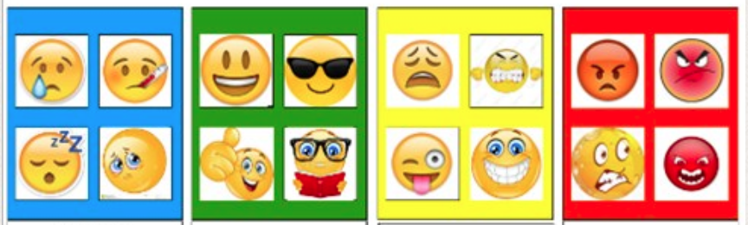
Children are taught that all zones are ok. It is important that adults don’t say things like, “What would help you get back to green?” as this implies the other zones are not desirable. Each emotion has its function. They are encouraged to develop their own individual toolkit of strategies to regulate their emotions that they can draw upon when they feel in a certain zone. For example, when they are feeling yellow, they might get up from their seat walk to the sink and have a drink whilst looking out of the window and connecting with nature for a moment. Below is an example of a toolkit.
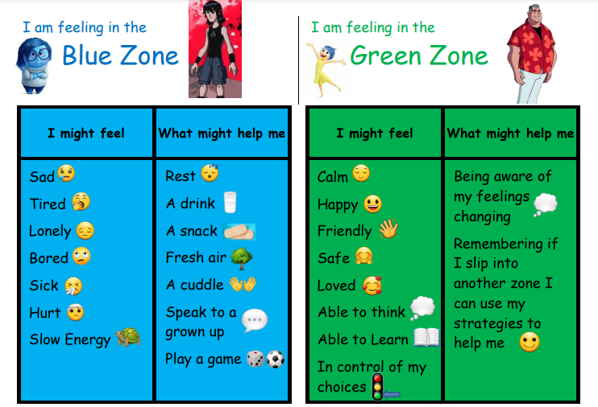
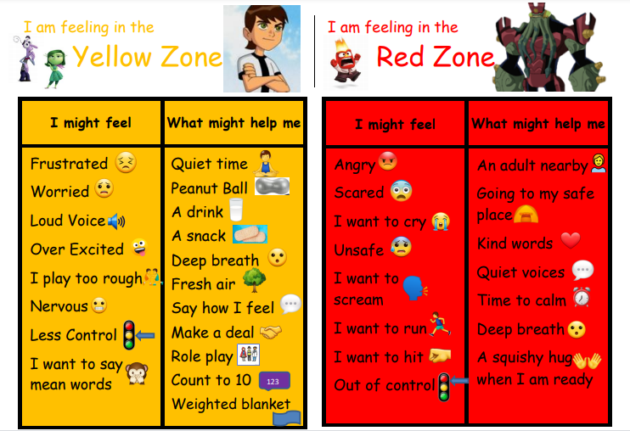
The Zones of Regulation was developed by Leah Kuipers and there is more information on this website:
https://www.zonesofregulation.com/learn-more-about-the-zones.html

