A Parents and Carers Guide

to

School & Family Support

(SAFS)

at Baldwins Hill



A Parents and Carers Guide to School and Family Support (SAFS)

Who is who in the School and Family Support Team?

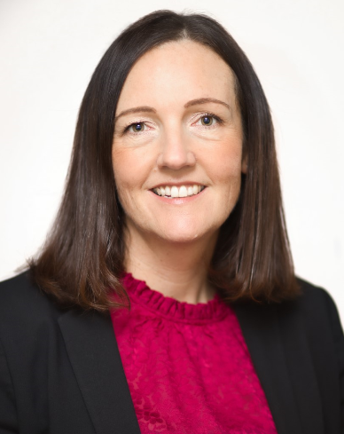 | 
Mrs Emily Webster  Head of Trust Inclusion/SENCo | Miss Helen Piper  Inclusion& Safeguarding Practitioner
 | 
Mr Nick Gedye  Disadvantaged Champion | Mr Nick Gedye  Special Educational Needs (SEN) Champion
 | 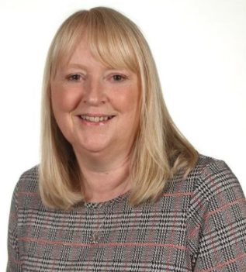
Mrs Sarah Brewer  Learning Mentor | Mrs Sally Sargent  Specialist Teaching Assistant

A Parents and Carers Guide to Student and Family Support (SAFS)

What is the Student and Family Support (SAFs) team?

The SAFS team is a team of professionals who work within school. They meet together in school regularly. The team plan for children who need extra support. There are various needs such as social and emotional, cognition and learning difficulties like Dyslexia, speech and language difficulties, medical issues, English as an additional language, and behavioural needs. The SAFs team review support provided within school and when necessary, make referrals to outside agencies such as our school nurse or speech and language therapist.

How does a child receive support from the SAFs team?

If your child’s class teacher is concerned about their progress or needs they will start to implement strategies that are shared in our School and Family Support Handbook. These will be recorded on a chronology as part of the Assess-Plan-Do-Review cycle. We ask class teachers to do two cycles of this process. If they are still concerned, even with some adaptations, then we encourage teachers to speak to parents and together complete a commissioning form to engage the SAFS team. Once the team receive this form they will review what has already been tried and suggest some next steps. The SAFS team will work with the class teacher to implement these next steps and they too will be reviewed after an agreed period of time.

Your first point of contact for your child is always their class teacher. If you would like to contact a member of the SAFS team please email the school office.
A Parents and Carers Guide to Student and Family Support (SAFS)

What is a SAFS commission?

The class teacher will meet with you to raise their concerns and discuss what has already been tried. A commissioning form will be completed to request that the SAFs team review the child’s difficulties and support in the planning of next steps to support your child. You will be asked to contribute to the commissioning form by completing a questionnaire to fill in with details of any concerns you may have. When this is returned to the teacher they will complete the same questionnaire and list the concerns that have been shared with you. The form will then be submitted to the SAFS team to be reviewed.



My child isn’t displaying any difficulties at school but I am concerned about them at home.

If this is the case please discuss this with your child’s class teacher. If together you decide that some extra support at school would help a SAFs commissioning form can be completed. Once the SAFS commissioning form has been returned it will be reviewed by the SAFs team and a conversation with you about next steps will be offered.

In some circumstances the class teacher may signpost another point of contact to support you, for example your child’s GP or the Integrated Front Door (IFD) as often they can offer advice and support.

Your first point of contact for your child is always their class teacher. If you would like to contact a member of the SAFS team please email the school office.
A Parents and Carers Guide to Student and Family Support (SAFS)

How will I know what is decided regarding next steps?
Either you child’s class teacher or a member of the SAFS team will contact you directly. If an outside agency needs to be involved through a referral we will seek your permission to do this. We may also ask for permission to complete some further assessments to give us more information in order to help us support your child. These may be done by their class teacher, teaching assistants or a member of the SAFS team. During this time you will be kept informed and next steps will be discussed with you throughout.

What happens after the SAFS commission?

Some children may need a higher level of ongoing support in order to make progress. (This will be assessed by using screeners, checklists and through consultation with outside agencies.) The SAFS team, in collaboration with you, may place your child on our Special Educational Needs (SEN) register. The SEN register is a list of children who need additional support. It means children are tracked carefully and support is planned. There are different levels of need on the register – see more details below.

All children receive quality first teaching. Some children may be discussed at an achievement team. A few children (usually less than 15-20% of the school population) are placed on the SEN register (of which there are 4 levels school support 1,2 and 3 - see below) and those with an Education Health and Care Plan (EHCP). The children with an Education, Health and Care Plan is around 2% of the school population.

Quality First Teaching - Universal

Achievement Teams

School Support 1

School Support 2

School Support 3

EHCP

A Parents and Carers Guide to Student and Family Support (SAFS)

What support is offered to children on the SEN register?
Every child on the SEN register will have either an Individual Learning Plan (ILP) or a Provision Document (PD). These documents show their individual support. They are bespoke plans designed around your child’s needs. The SAFS team will support in their preparation using their experience and expertise in supporting children with special educational needs.
The difference between an ILP and a PD is the amount of detail and the frequency of how often they are reviewed (see below for details).
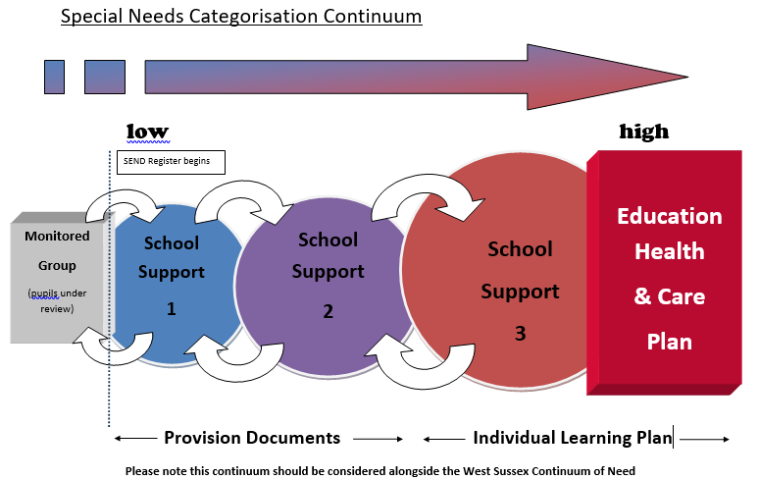
If you are unsure about which level of need your child is on, please ask your child’s teacher – this is recorded on the inclusion register.
A child will only move from one level to another if they are not making progress. Once school support 3 has been reached, in very rare circumstances when no progress is made despite high levels of support after discussion together we may decide to apply to West Sussex County Council for a Needs Assessment (EHCNA) which may lead to an Education, Health and Care Plan (less than 3% of the school population). See more information in the link below. https://westsussex-local-offer.s3.amazonaws.com/public/system/attachments/1207/original/Guidance_and_Criteria_for_EHC_Needs_Assessments_%28updated_Aug_18%29.docx

A Parents and Carers Guide to Student and Family Support (SAFS)

What are the different levels of need?
The table below shows the level of need, the criteria for that need, the plan that will be written by school and parents/carers and how often the plan will be reviewed.

Level of Need | Criteria | Plan written | Timescale for review
School Support 1 | Continuous support in school for at least two terms  (beyond quality first teaching) | Provision Document | Yearly or if something changes
School Support 2 | One agency involved | Provision Document | Yearly or if something changes
School Support 3 | More than one agency involved  OR  Two years behind peers | Individual Learning Plan | Termly
Education, Health and Care Plan | Multiple needs and agencies – gained through an application to WSCC for a needs assessment | Individual Learning Plan | Termly or as required

What support for parents/carers?
There are Inclusion Parent Forums which are held at least each term. These forums give parents the opportunity to meet with members of staff from the SAFS team, get information and advice on various topics, receive updates from the academy and meet other parents. It is an opportunity for parents to offer support and advice to each other.



A Parents and Carers Guide to Student and Family Support (SAFS)

What other support is available for parents/carers?

There are links on the school website for the Local Offer and agencies which can offer further support and advice. The Local Offer gives children and young people with special educational needs or disabilities and their family’s information about what support services the local authority think will be available in their local area. Please see the school website - Key Information - Inclusion tab.

In addition there is an active Facebook page where parents offer each other support with Inclusion. Please contact the school office for more details.

We are always here to support parents so if there is anything you need please do ask.



If you would like to contact a member of the SAFS team please email the school office.

Baldwins Hill Primary School
01342 321572
officebh@partnersinlearning.co.uk

