Maths  We are currently working on counting and recognising numbers to 10.  How can I help my child?  - Practice number recognition. You could look at house door number when you are out walking.  - Practice counting objects, for example Lego pieces when making a tower, pasta tubes to string on a shoe lace. | Personal Social Emotional Development  We will be focussing on how to show the core values, settling in and making friends.  How can I help my child?  Talk with your child about what they are good at? | Physical Development  We will be using funky finger activities, and write dance to develop our fine motor skills so that we can hold pencils properly.  We will do yoga and gym activities to experiment with what different parts of our bodies can do.  How can I help my Child?  - Use playdough to strengthen fingers.  - Encourage your child to be active.
Communication and Language, Literacy  We will be learning to write our names, have lots of mark making opportunities and discuss ‘Our Journey’ booklets.  How can I help my child?  - Talk about their day.  - Read for 10 minutes with your child. | EARLY YEARS: Autumn 1  This is Me!  What makes me marvelous?  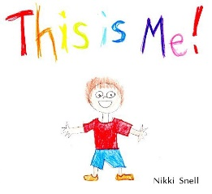 | Understanding the World  We will be learning about different parts of our body and how to keep healthy.  How can I help my child?  - Play games /sing songs such as Simon says and head shoulders knees and toes.
Expressive Arts and Design  We will be exploring colour mixing and painting our own self portrait.  How can I help my child?  - Draw pictures of the people in your family.  - Talk about how people in your family look similar and different. | Learning and life skills – Learning together.  We will be working on learning together as a class during class assembly and free learning time.  PE days  Tuesday and Friday  Children to come in wearing PE kit. | Stunning start  Discussing our ‘Journey booklets’ to get to you know each other.  Fabulous Finish  We will be creating a self-portrait for our art gallery  PE days  Monday and Wednesday. Please come to school dressed in PE kit on these days.

